Tentative 2013 Race Calendar

Winter

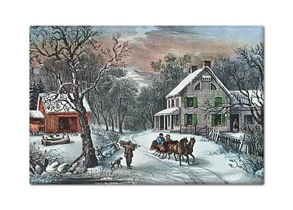

January 1: Predict Your Time 5k- 11am @ the Danville Biscuitville on Rt.58

February 16: Valentine’s 14k- 10am @ the Ringgold Railroad Depot

March 2: Hope for the Homeless 5k- Martinsville

March 9: Green Legs and Hamstrings Trail Races- 5k, 10k, and half marathon.
10am @ Anglers Park

March 10- SVMBA Mountain Bike Event @ Anglers Ridge

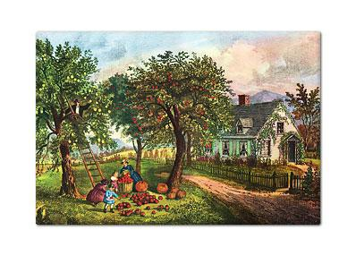
March 16: Shamrock 5k (race 1 of 7 in the DRFC Points Series) Spring

March 23- Martinsville Half Marathon and 5k

March 30- Goodyear Education 5k- @ the Goodyear Golf Course. (Race 2 of 7 in the DRFC Points Series)

April 13- Bridge to Bridge 5k and 10k- @ the Crossing in Danville

April 20- Earth Day 5k- Martinsville

April 27- Autism 5k- @ the Crossing in Danville

May 11- Gretna 5k

May 18- Nestle 5k- @ Ballou Park in Danville. (Race 3 of 7 in the DRFC Points
Series)

June 8- South Boston YMCA 5k

Summer

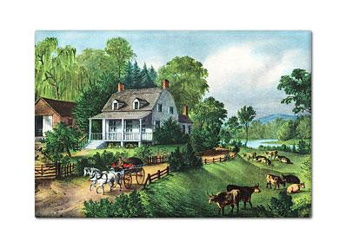

June 22- DCC Run for Justice 5k and 10k- @ Anglers Park. (Race 4 of 7 in the DRFC Points Series)

July 4- Patriot Challenge 5k Trail Race- @ Anglers Park

Autumn

September 7- River City 5k. @ Anglers Park. (Race 5 of 7 in the DRFC Points
Series)

September 14 N.C./VA. Road Race 5K/15K @ Miller Brewery
This is the revival of the Old N.C./VA. Road Race of the late 80’s & early 90’s

September 21- SVMBA Mountain Bike Event @ Anglers Ridge
October 12- 10k Road Race - Downtown Danville (the old Dan River Runs Deep course).

October 19- Great Goblin Gallop- Martinsville

October 19- Run for Life 5k- South Boston

October 26- Danville Half Marathon and 5k. (Race 6 of 7 in the DRFC Points
Series)

November 2- Louie Fields 5k. Danville. (Race 7 of 7 in the DRFC Points Series) November 2- Dirty Dan Dash. @ 1pm
November 9- Reidsville Turkey Trot 5k

Stay tuned for updates as the year rolls along…

